Nama : Siti Fauziyah

NIM : 18090019

Kelas : 5B

**Laporan Pratikum 2**

1. Source Code

Latihan1.php → controller

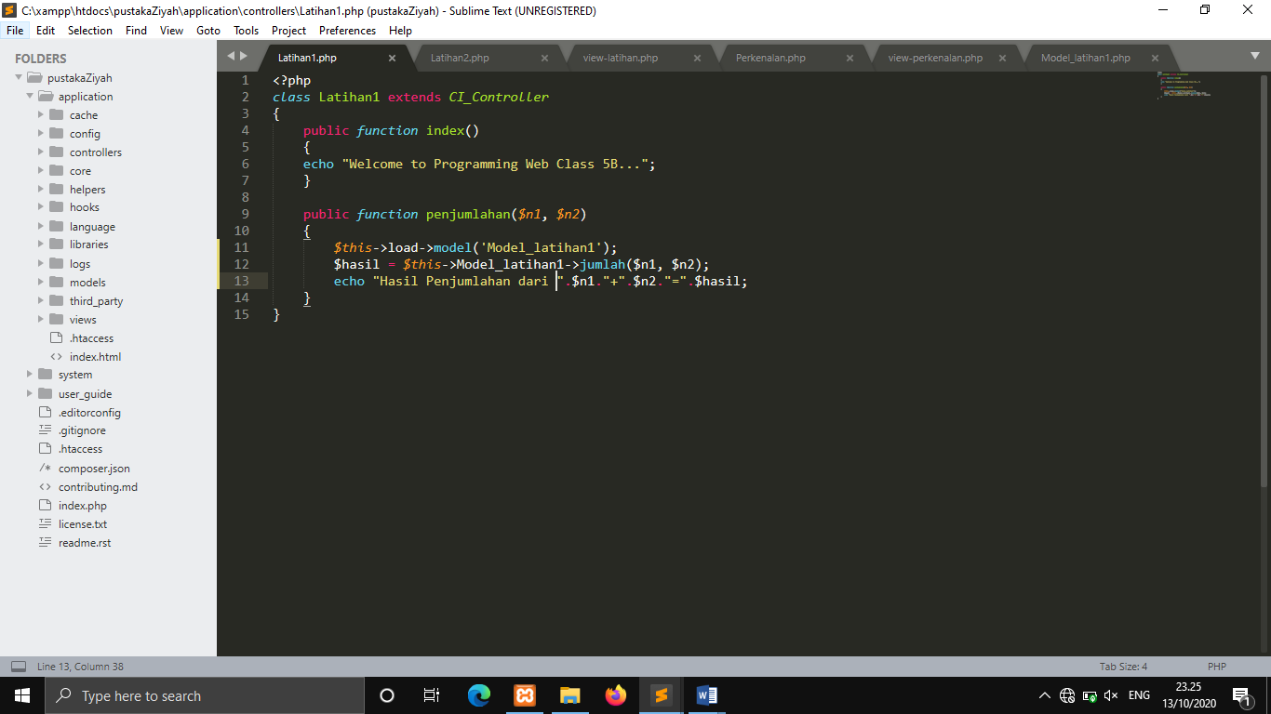

Latihan2.php → controller

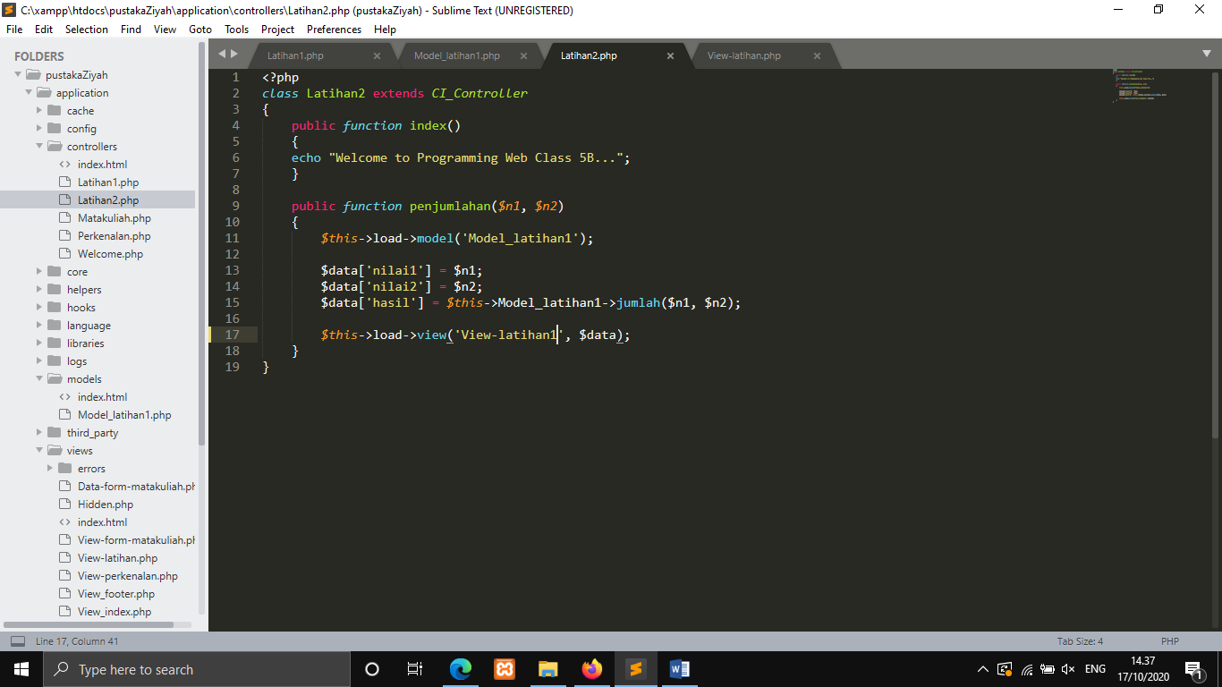

Model_latihan1.php → models

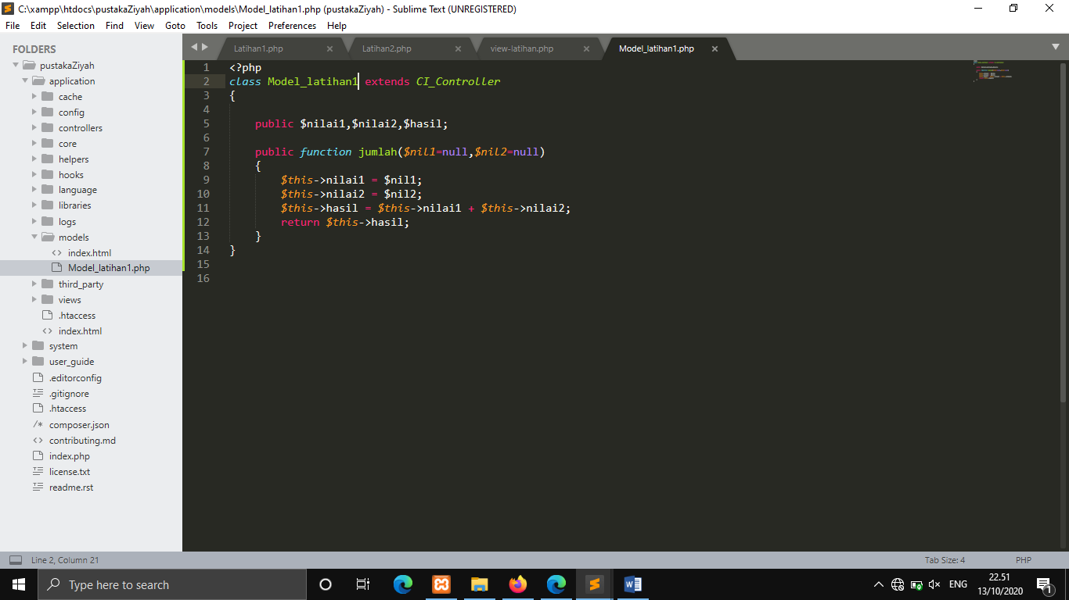

View-latihan.php → views

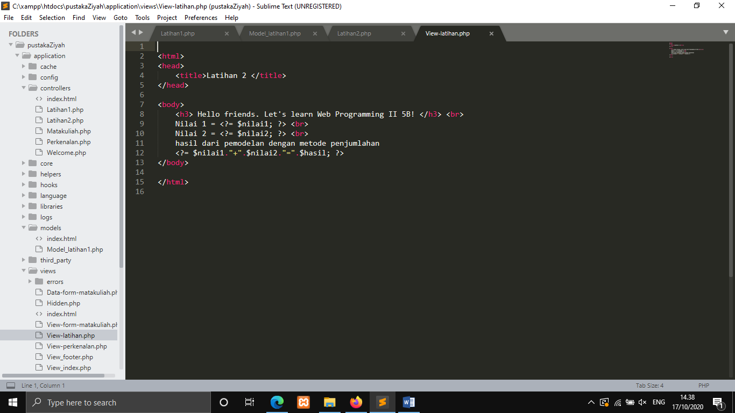

1. URL

<http://localhost/pustakaZiyah/index.php/Latihan1/Penjumlahan/1/7>

<http://localhost/pustakaZiyah/index.php/Latihan2/Penjumlahan/32/50>

1. Capture Output Program

Latihan 1

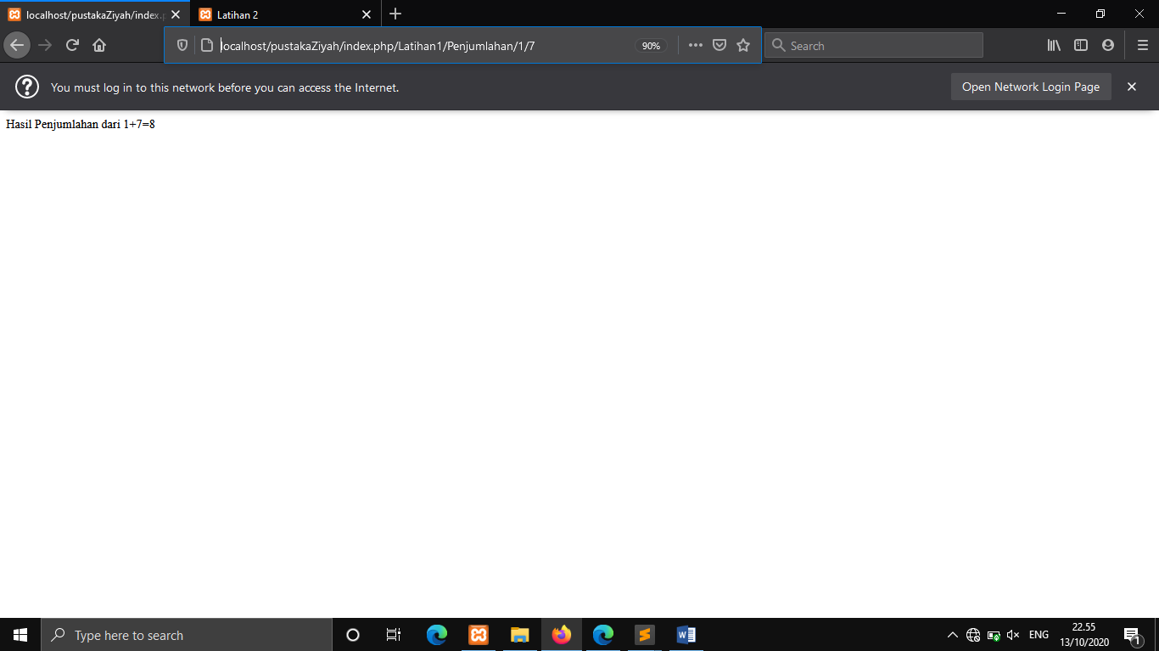

Latihan 2

